**LAPORAN PRAKTIKUM LATIHAN**

Pemrograman Berbasis Web

Pertemuan 04



Oleh :

NAMA : FARAH TRI MAHARDINI

NPM : 4522210042

Dosen:

**Adi Wahyu Pribadi ,S.Si.,M.Kom**

**S1-Teknik Informatika**

**Fakultas Teknik Universitas Pancasila**

**2023/2024**

51.1 Membuat Aplikasi Web Sederhana

Cth.go

|  |
| --- |
| package main  import "fmt"  import "net/http"  func index(w http.ResponseWriter, r *http.Request) {      fmt.Fprintln(w, "apa kabar!")  }  func main() {      http.HandleFunc("/", func(w http.ResponseWriter, r *http.Request) {          fmt.Fprintln(w, "halo!")      })      http.HandleFunc("/index", index)      fmt.Println("starting web server at http://localhost:8080/")      http.ListenAndServe(":8080", nil)  } |

Screenshoot

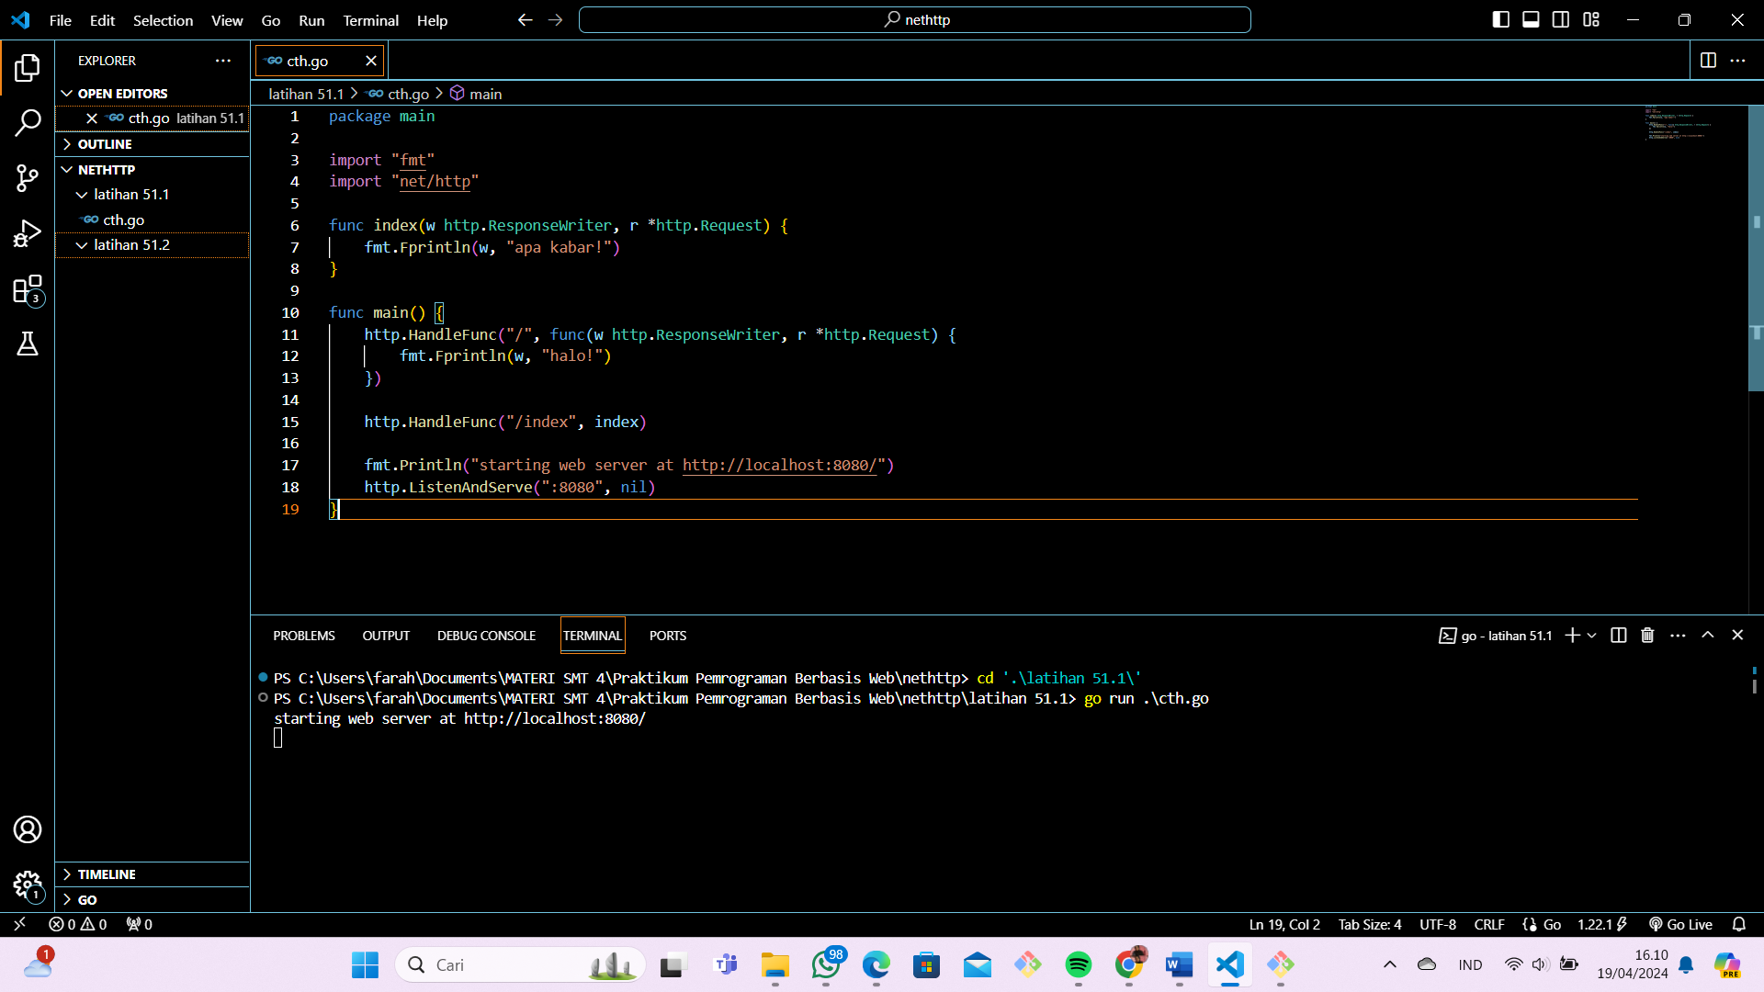

Hasil Run

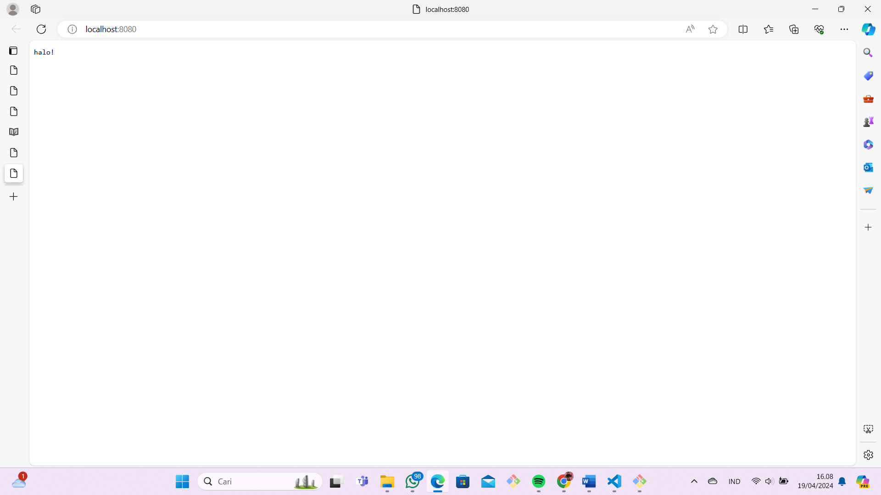

Di tambah indeks agar keluar “apa kabar”

|  |
| --- |
| package main  import (      "fmt"      "net/http"  )  func index(w http.ResponseWriter, r *http.Request) {      fmt.Fprintln(w, "apa kabar!")  }  func main() {      http.HandleFunc("/", func(w http.ResponseWriter, r *http.Request) {          fmt.Fprintln(w, "halo!")      })      http.HandleFunc("/index", index)      fmt.Println("starting web server at http://localhost:8080/index")      http.ListenAndServe(":8080", nil)  } |

Hasil Run

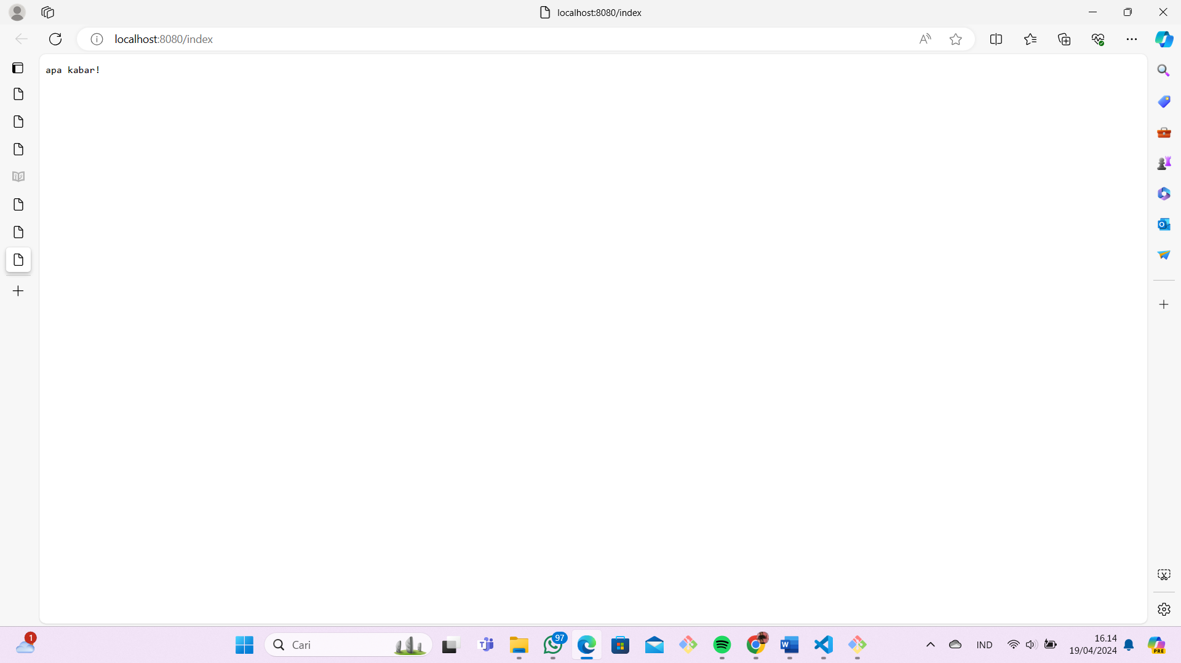

51.2 Penggunaan Template Web

Buat file template.html

|  |
| --- |
| <html>      <head>          <title>Go learn net/http</title>      </head>      <body>          <p>Hello {{.Name}} !</p>          <p>{{.Message}}</p>      </body>  </html> |

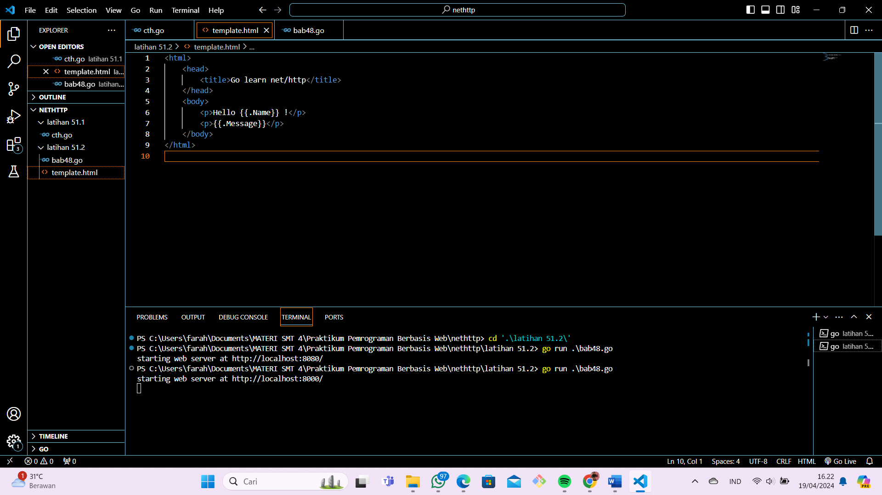

Buat file bab48.go

|  |
| --- |
| package main  import "fmt"  import "html/template"  import "net/http"  func main() {      http.HandleFunc("/", func(w http.ResponseWriter, r *http.Request) {          var data = map[string]string{              "Name":    "john wick",              "Message": "have a nice day",          }          var t, err = template.ParseFiles("template.html")          if err != nil {              fmt.Println(err.Error())              return          }          t.Execute(w, data)      })      fmt.Println("starting web server at http://localhost:8000/")      http.ListenAndServe(":8000", nil)  } |

Screenshoot

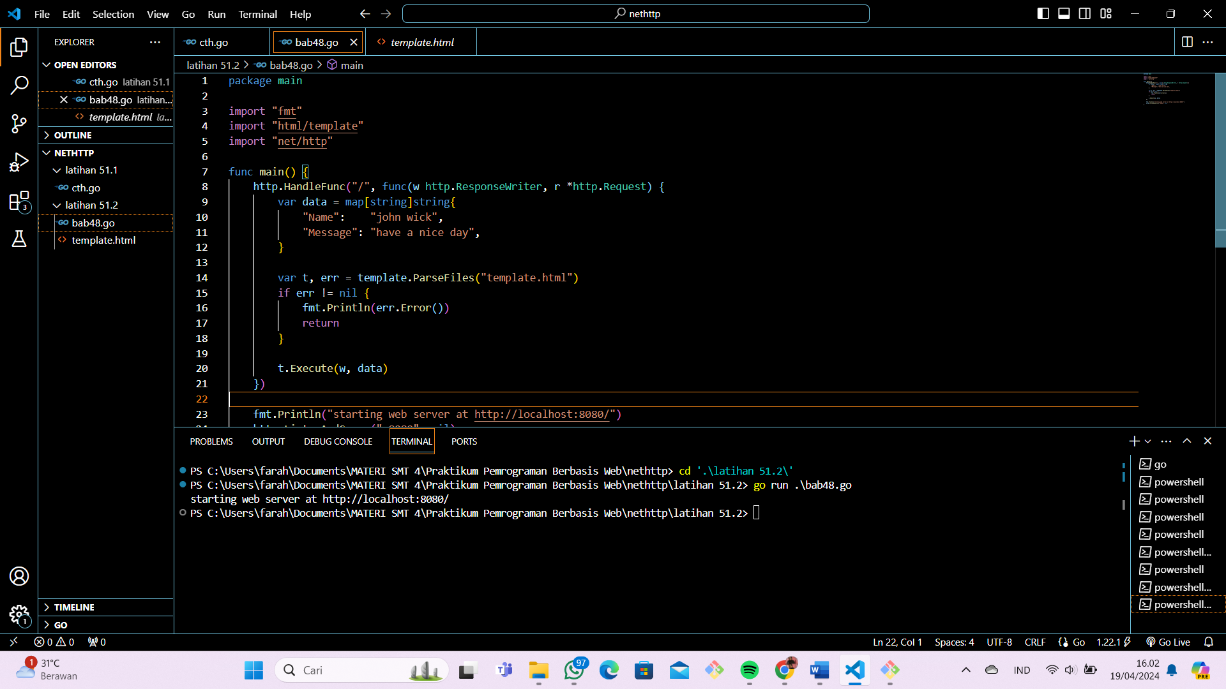

Hasil Run

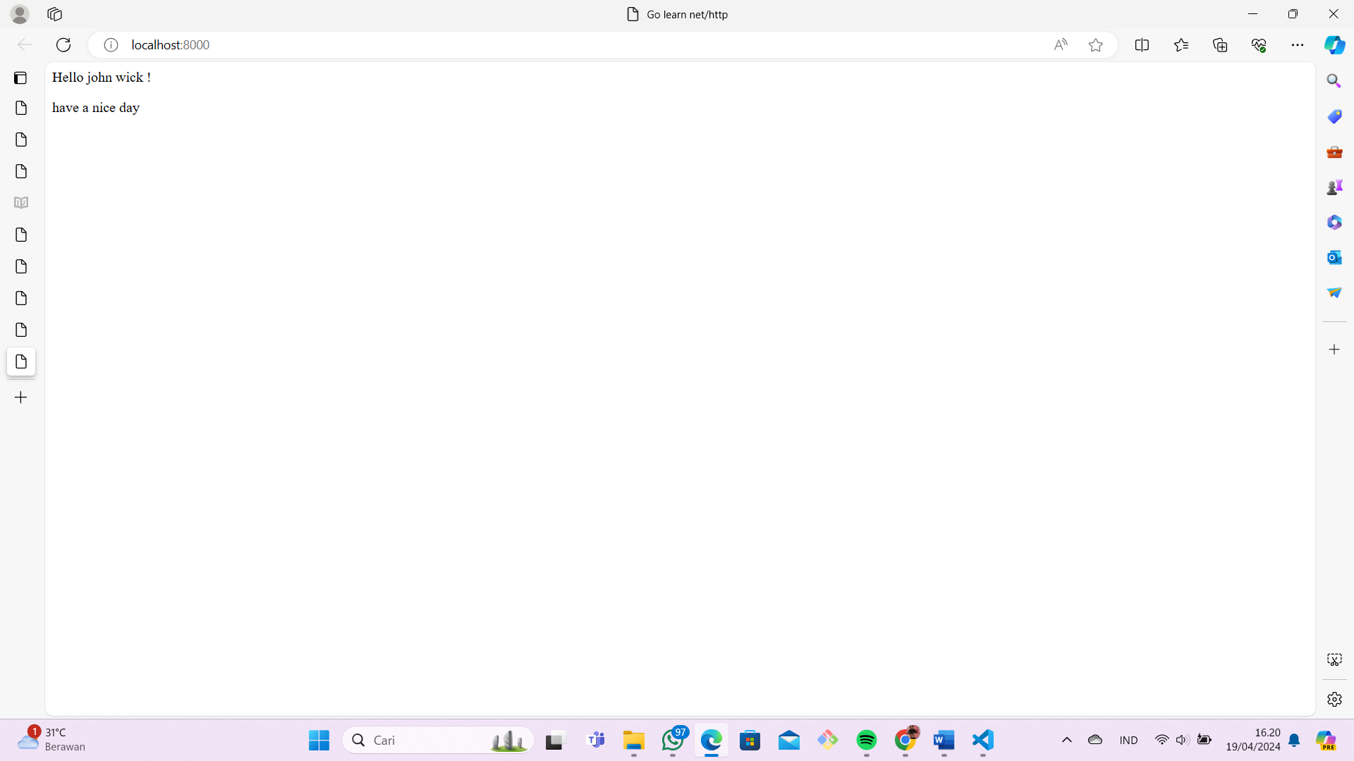

LINK GITHUB: